Dharmendrasinhji Arts College, Rajkot
Dr. Yagnik Road, Ph./Fax No. (0281) – 2465632
Govt. Of Gujarat
(Affiliated with Saurashtra University)

7.1.4 - Water conservation facilities available in the Institution:
- Rain water harvesting
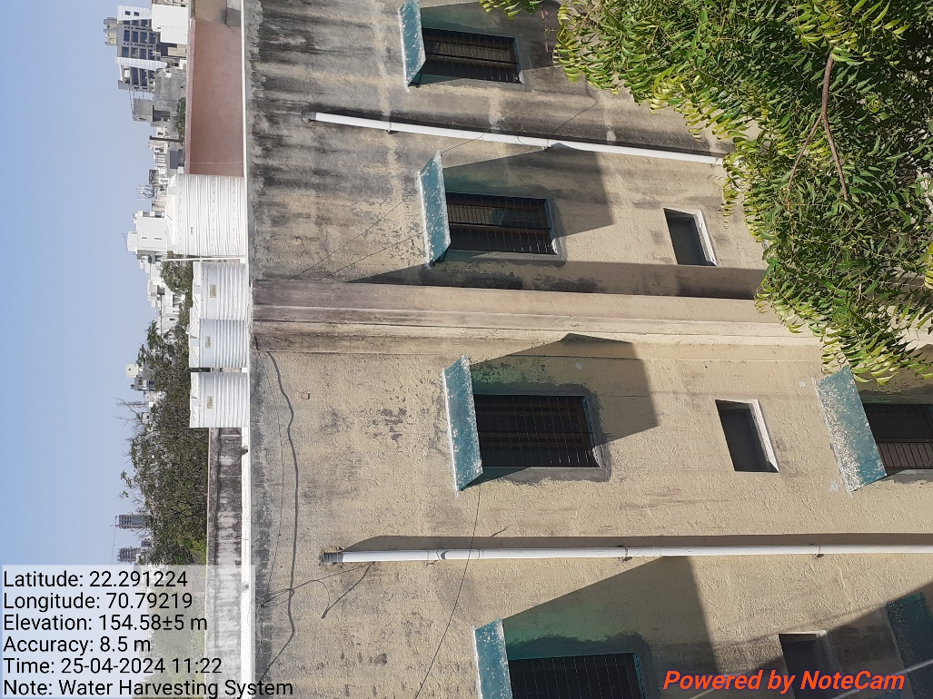

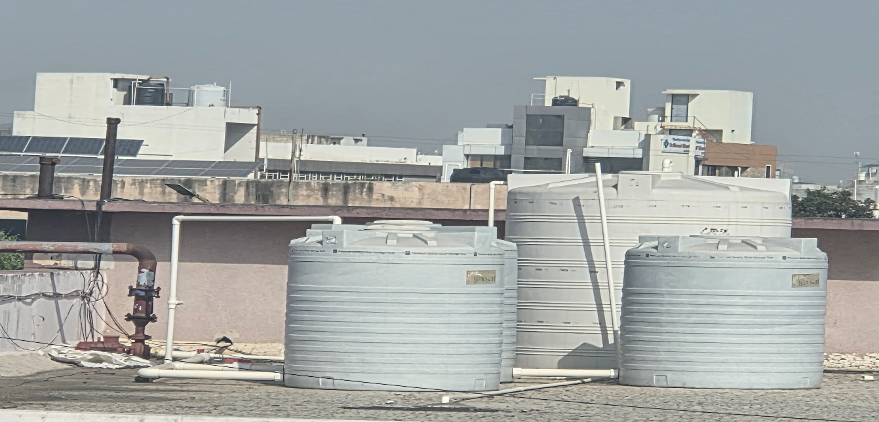
- Bore well /Open well recharge

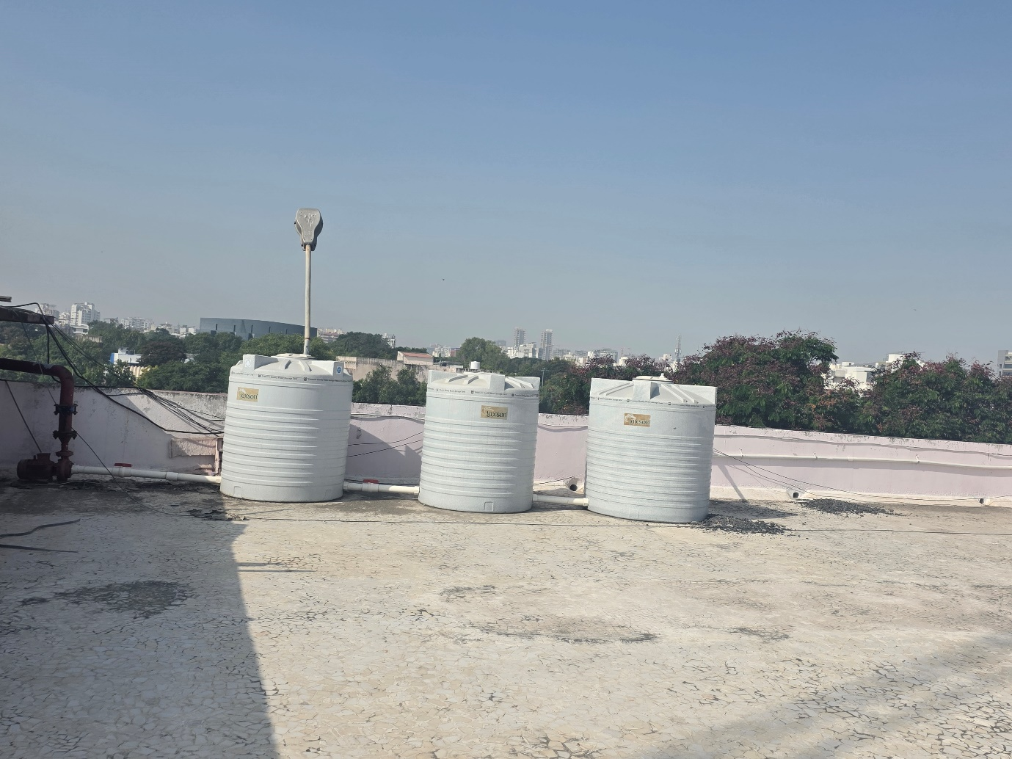
- Construction of tanks and bunds

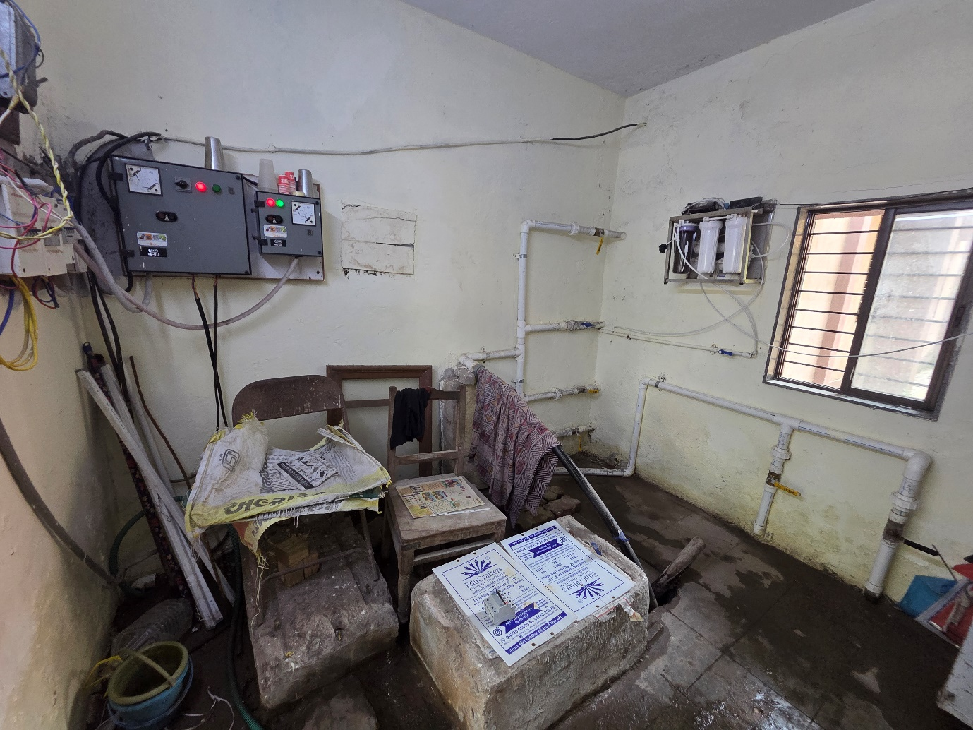
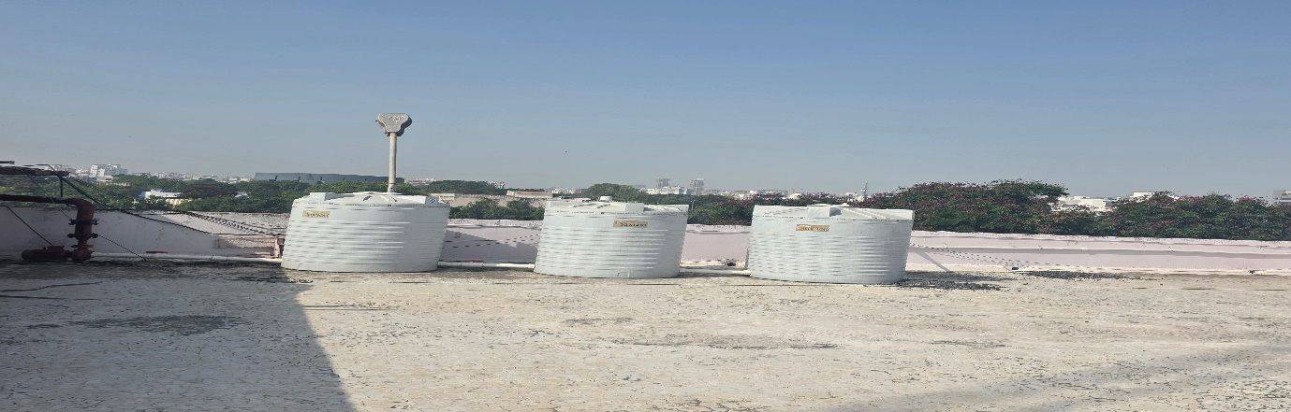
- Maintenance of water bodies and distribution system in the campus

